Data procedures:

1. Data was collected and given by UpGrad (E-learning platform) while undertaking module 7 of ‘Business Analytics’ course.
2. Received on 26th Aug,2020
3. Spreadsheet name ‘Module 7.2 Courses.xlsx’

Calculations:

1. Added new column “Branch”.
2. Separated column “Courses” into “Courses” and “Branch” using delimiter ‘-’ (Before calculation)
3. New column “CourseID_branch” was added. Formula used CONCAT(A2,"-",B2)

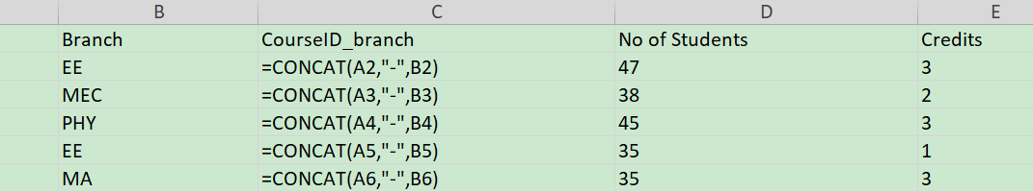

Insights:

1. To calculate the most popular branch using pivot table:

Pivot table was created in a new sheet named “Branch”.

